Zion Evangelical Lutheran
13511 Roland Lake Road
Skanee, MI 49962

November-December 2023

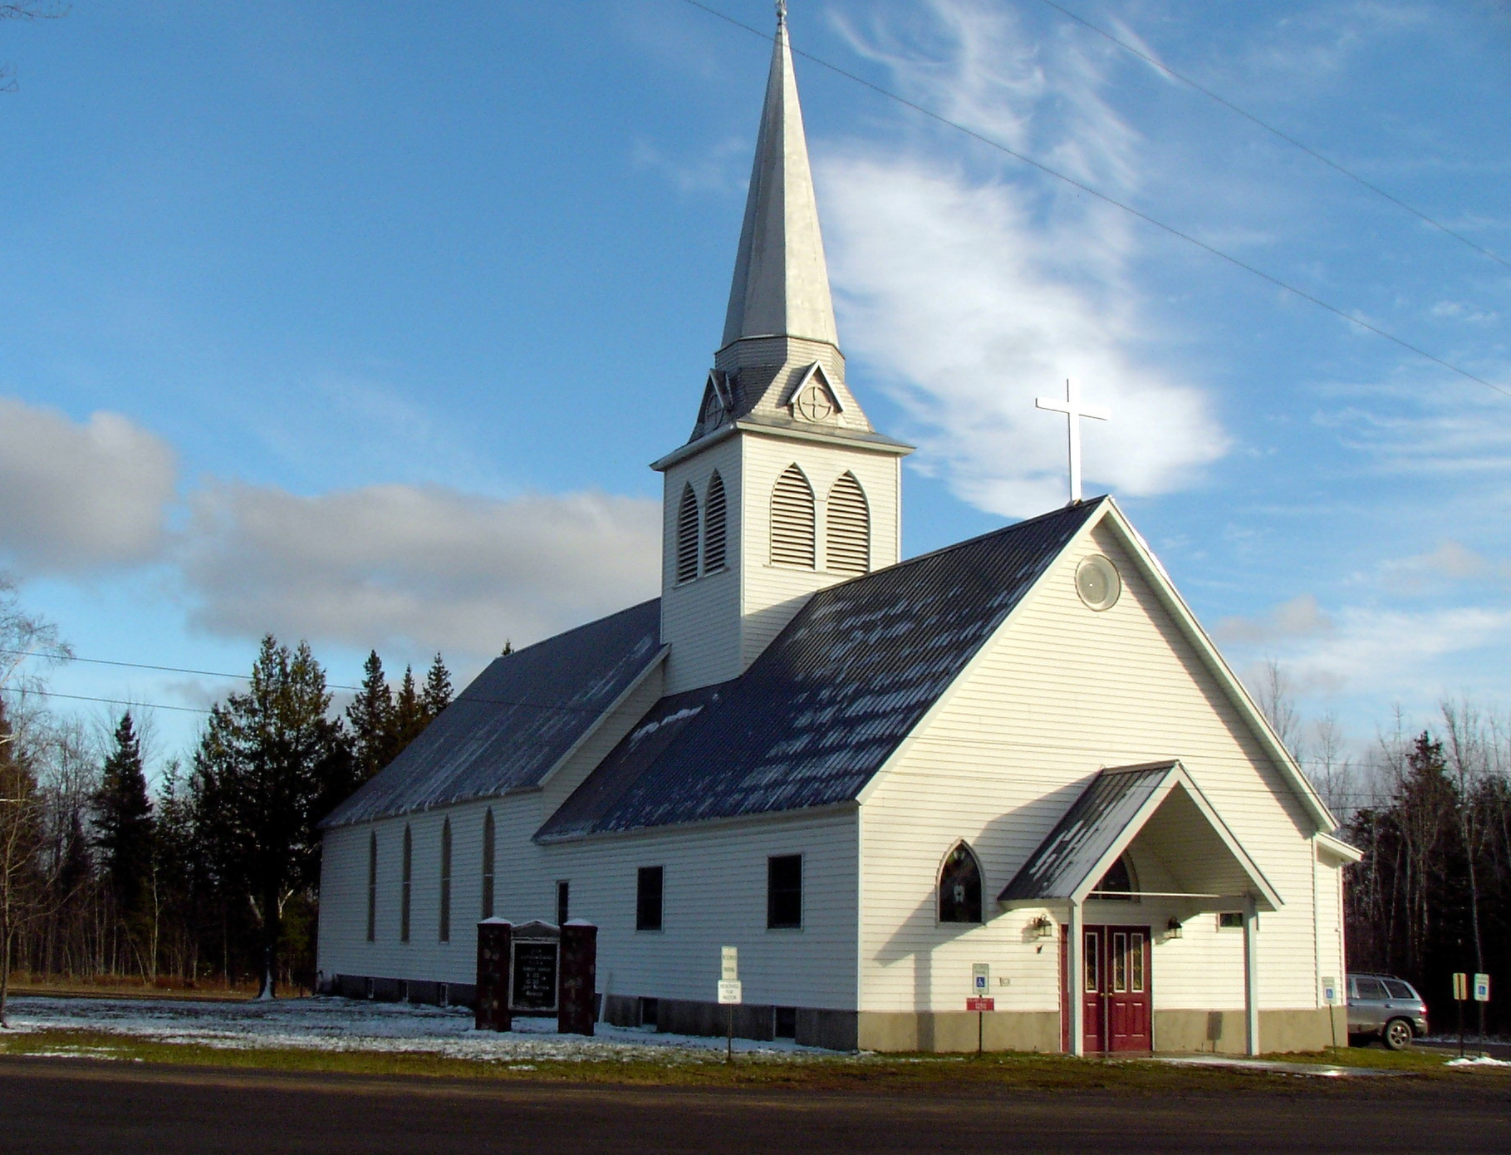

Zion Lutheran Church
13511 Roland Lake Road
Ph: 906-524-6524
Email: zionlutheranskanee@gmail.com



November-December
Worship will be at 10 a.m. in the Sanctuary

Mid-week Advent Soup Supper and Worship
Soup Supper at 5 pm
Worship at 6 pm
Dates to be determined.
Watch Sunday bulletins, Zion’s Facebook page, and website
for more information.


Turn Clocks Back One Hour
Don’t forget to turn your clocks back one hour on Saturday, November 4th before you go to sleep.


Church Office Closed
The church office will be closed on Monday, December 25th and Monday, January 1st.

COUNCIL MEETING
Council Meetings will be November 12th and December 10th following worship (11:15 a.m.)


LET US PRAY…. (prayer is service to God and community)
Michael Bonini, Bonnie Butterworth, Jim Cooley, Ethel Kovala, Roger Jordan, Doug Jukkala, Kathy Magnant, Judy Mattson, Clifford Nankervis, Wayne & Karen Nelson, Dan Roth, Lois Roth, Cheri Snider, Fawntelle Williams.

(Please take the time to visit our shut-ins – they are a part of our church family and need your prayers, your support, and your love)

All of our military personnel.
Congregations: Wainola Lutheran Church; Bethany Lutheran, Covington; Aura Lutheran Church; Kemi Lutheran Church, Russian Karelia.

(Please keep Lisa up-to-date on who should be added or removed on this list) zionlutheranskanee@gmail.com
.

Dear God, I humbly ask that you heal us from hurt, shame, sickness, and guilt. Heal our hearts, O Lord God. Give us beauty for ashes, the oil of joy for mourning, and let us wear the garment of praise instead of the spirit of heaviness and burden. I pray in Jesus name. Amen.

Family Emergencies, Hospitalizations, or Deaths
Peter Suomela or the church office when these events occur. Our goal as the body of Christ is to provide timely Pastoral Care, Prayer, or Presence in your time of crisis based upon your need.

PLEASE NOTE: At this time, if you are requesting a visit for someone in the hospital, please make the request to the hospital that you would like Peter Suomela to visit.

Bible Readings for November-December

November 5 Revelation 7:[2-8] 9-17
Psalm 149
1 John 3:1-3
Matthew 5:1-12
November 12 Amos 5:18-24
Psalm 70
1 Thessalonians 4:13-18
Matthew 25:1-13
November 19 Zephaniah 1:7-16
Psalm 90:1-12
1 Thessalonians 5:1-11
Matthew 25:14-30
November 26 Ezekiel 34:11-16, 20-24
Psalm 95:1-7a
1 Corinthians 15:20-28
Matthew 25:31-46
December 3 Isaiah 64:1-9
Psalm 80:1-7
1 Corinthians 1:3-9
Mark 13:24-37
December 10 Isaiah 40:1-11
Psalm 85
2 Peter 3:8-14
Mark 1:1-8
December 17 Isaiah 61:1-4, 8-11
Psalm 126
1 Thessalonians 5:16-24
John 1:6-8, 19-28
December 24 Isaiah 7:10-14
Psalm 110:1-4
1 John 4:7-16
Matthew 1:18-25
December 31 Isaiah 61:10-62:3
Psalm 111
Galatians 4:4-7
Luke 2:22-40



JUST A REMINDER
The Suggestion Box, located in the narthex, is still there… Please put any suggestions you have for growing the church. We have received some suggestions already and plan to implement some of them. It will take a little planning to implement a couple of the others, but are excellent ideas and we hope to move forward with them. We thank you so much for making the suggestions. Just know that we need everyone to be involved as much as possible. Some can give of their time and talents more than others, but that is ok, too. We want you to know that it will all be appreciated.

SERVICE OPPORTUNITIES
Altar guild sign up is in the narthex. If you desire training, please see Sue Bollech.
The choir is always appreciative of new members; see Linnea Barron.

Ivy’s Acrostic Poem
By Ivy Mae Huttema
God loves it when we take our thoughts to Him in prayer.
Is there more though? Are there other things we should be doing when we pray?
Various Bible verses teach us how to pray. Matthew 6:9-13 is Jesus’s example of prayer.
Even though we know God will provide us with our needs, He still wants us to ask.

Understanding that we do not demand anything from God is key to prayer.
Simply request your daily needs from God. He will provide as long as you abide by Him.

The Lord’s Prayer’s fifth petition is, “Give us this day our daily bread.”
How is this relevant to our discussion?
It is Jesus’s way of asking his father for his daily needs.
Since God is our heavenly father, we should request our needs and desires like a child.

Do not expect God to give you his gifts if you do not ask.
A good thing to remember, is that God will never force his gifts on anyone.
You need to pray to God with sincerity and love in order to receive his gifts.

Our anxiety is important to God too.
Underestimating God’s love by believing he doesn’t care about our emotions is wrong.
Remember that God sent His only son to die on a cross to forgive us our sins.

Do not hesitate to take your worries and anxiety to God.
A prayer doesn’t have to have fancy words to make it relevant to Him.
If the words are pure and come from your heart, God will listen to them.
Love the Lord with all your being because he created you and wants you to be happy.
You never need to worry with God because He loves and understands you.

Be mindful of temptation.
Reach out to Him in Prayer.
Even if it’s the dead of night, He will hear you.
A pure sincere prayer from the heart, and full belief in Him is all we need to talk to Him.
Do not worry about the future, or the things of this world. Lay your worries down to Him.

“Give us this day our daily bread”

